**Project X: Automated Attendance System**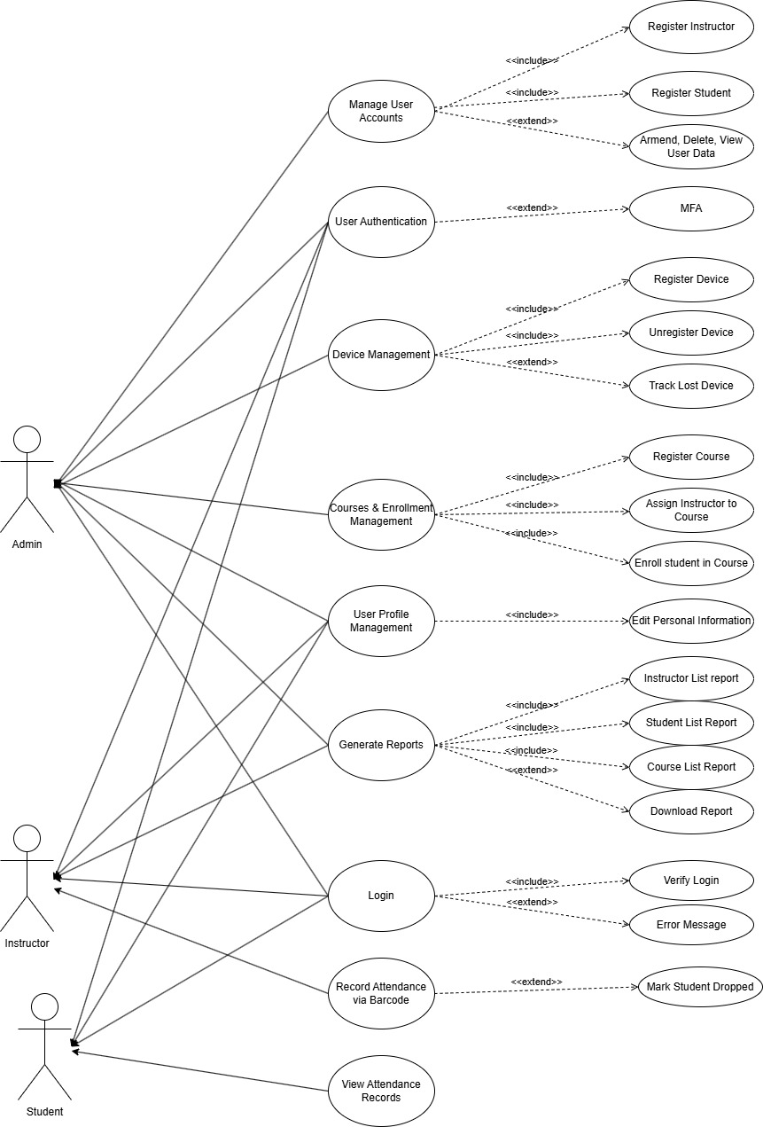

**High Level**

**Use Case Diagram**